**Design and Performance**

**User Manual**



Group 31

September 18, 2017

Contents

Included in the Package 3

Description of Parts 4

How to Use 4

Enter into Infrared Remote Control Mode 5

Enter into Bluetooth Mode 5

Enter into Ultrasonic Obstacle Avoidance Mode 6

Additional Function 6

Troubleshooting 7

Specification 7

Cautions 7

# Included in the Package

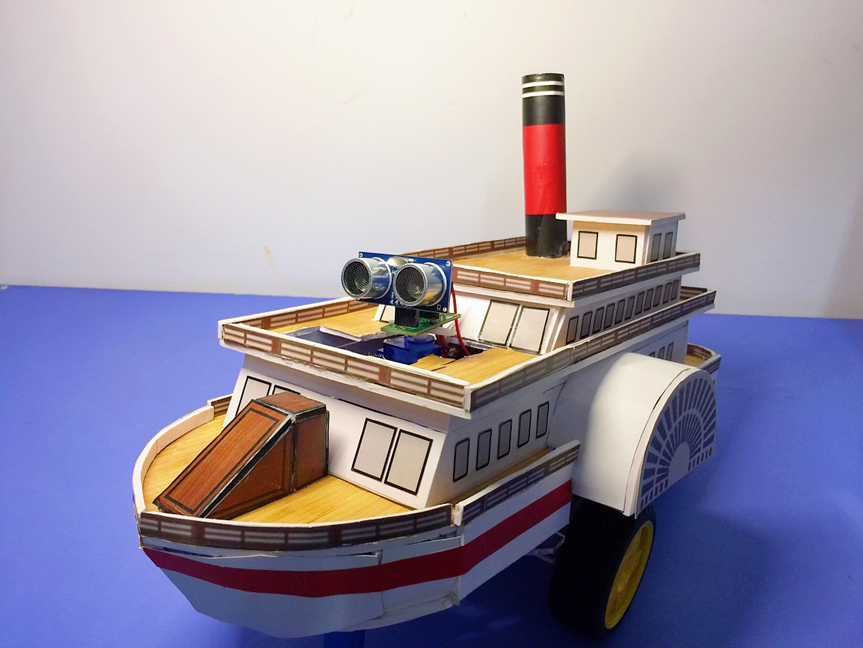

* A ship-shaped drawing robot.
* Two 3.7V rechargeable batteries.
* A battery charger.
* An infrared remote controller.

# Description of Parts

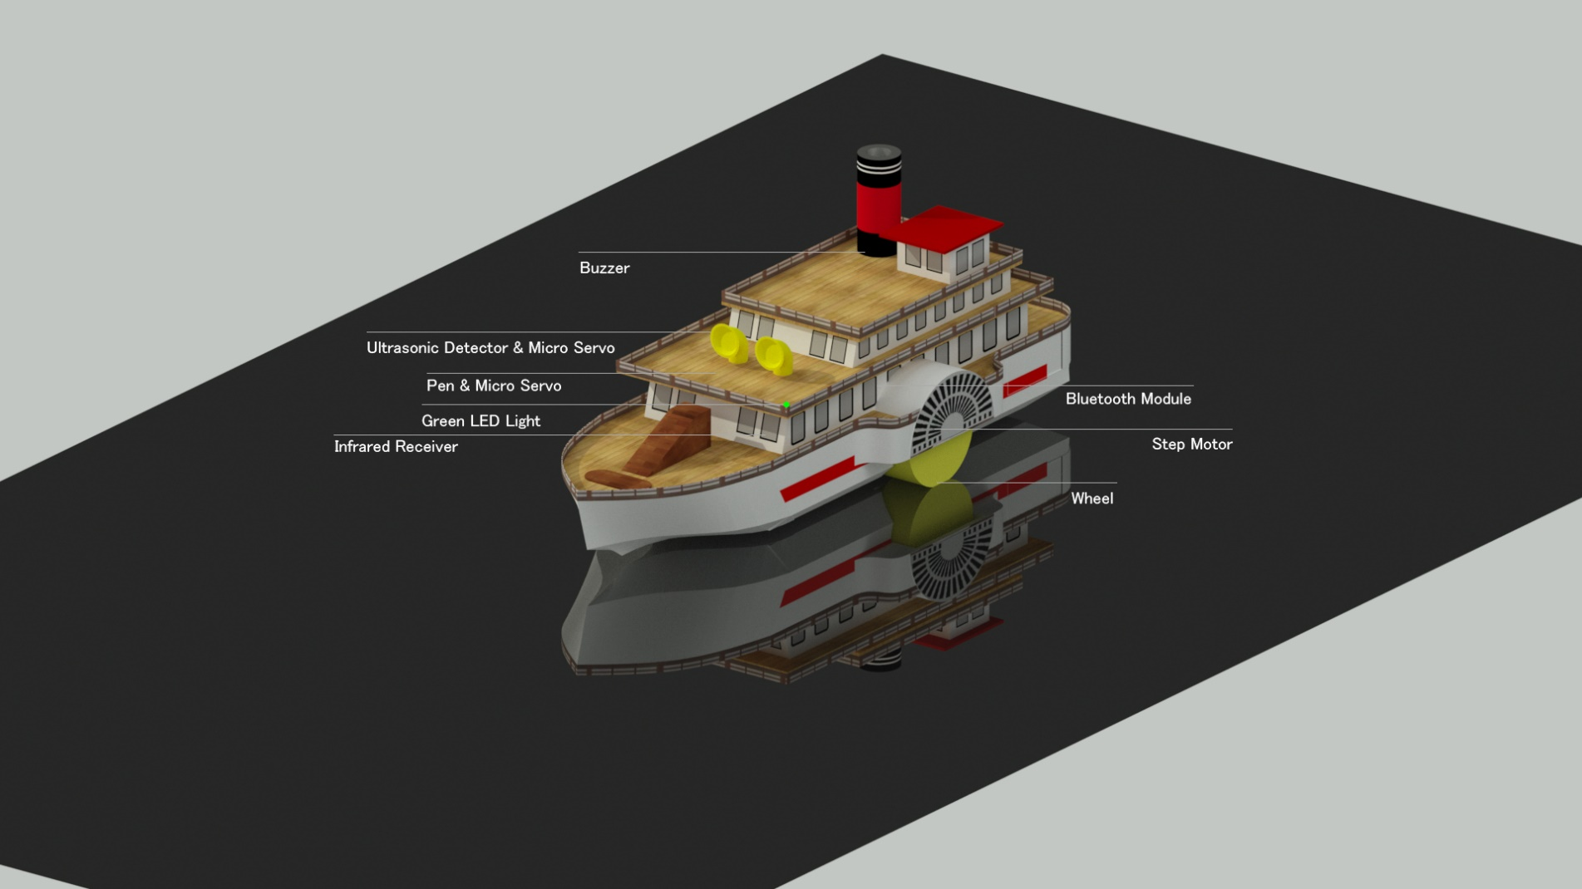

|  |  |
| --- | --- |
| **Parts** | **Function** |
| Green LED light | Show operation state via lighting and twinkling |
| Ultrasonic detector | Measure distance |
| Step motor | Spin two wheels |
| Wheel | Control the robot movement |
| Buzzer | Play music and warn |
| Bluetooth module | Transmit and receive the Bluetooth signal |
| Infrared receiver | Receiver the infrared signal |
| Micro servo | Control the pen |
| Pen | Draw the diagram you want |

Table 1

# How to Use

## Enter into Infrared Remote Control Mode

1. Install two batteries.
2. Press the corresponding key in infrared remote controller towards infrared receiver according to keyboard functions table.
3. If two wheels are rotating or the robot is playing music, the green LED light will keep lighting.
4. If two wheels stop, the green LED light will twinkle once.
5. If the robot enters into Bluetooth mode, the green LED light will twinkle twice.
6. If the robot enters into ultrasonic obstacle avoidance mode, the green LED light will twinkle three times.
7. If infrared receiver receives the wrong signal, the buzzer will warn.
8. Keyboard Functions Table

|  |  |  |
| --- | --- | --- |
|  | **Key** | **Function** |
| Draw a diagram | 1 | Draw a triangle |
| 2 | Draw a circle |
| 3 | Draw a square |
| 4 | Draw a rectangle |
| Play music | 5 | Play a song |
| User custom drawing | ▲ | Walk forward |
| ▼ | Walk backward |
| ◀ | Turn left |
| ▶ | Turn right |
| OK | Stop |
| 7 | Lift the pen |
| 8 | Put down the pen |
| Switch mode | * | Enter into Bluetooth mode |
| # | Enter into ultrasonic obstacle avoidance mode |

Table 2

## Enter into Bluetooth Mode

1. Ensure that you are already in infrared remote control mode.
2. Press * key to switch to Bluetooth mode.
3. If you can see the green LED light twinkle twice, you are in Bluetooth mode.
4. Download a Bluetooth software on your device.
5. Open Bluetooth on your device and search the robot Bluetooth named HC06, the default password is 0000.
6. After successfully connecting to Bluetooth, enter the appropriate letter in the dialog window or press appropriate key according to the Bluetooth functions table.
7. You will receive a response after every instruction.
8. Bluetooth Functions Table

|  |  |  |
| --- | --- | --- |
|  | **Key** | **Function** |
| Draw a diagram | T | Draw a triangle |
| C | Draw a circle |
| Z | Draw a square |
| J | Draw a rectangle |
| Play music | M | Play a song |
| User custom drawing | W | Walk forward |
| B | Walk backward |
| L | Turn left |
| R | Turn right |
| S | Stop |
| Q | Lift the pen |
| D | Put down the pen |
| Switch mode | U | Enter into ultrasonic obstacle avoidance mode |
| Exit | E | Exit Bluetooth mode and back to infrared remote control mode |

Table 3

## Enter into Ultrasonic Obstacle Avoidance Mode

1. You can enter into this mode via infrared remote control mode or Bluetooth mode.
2. Robot in this mode can automatically avoid obstacles to walk.
3. This mode doesn’t support music.

# Additional Function

1. User custom drawing.
2. Support Bluetooth mode.
3. Realize ultrasonic obstacle avoidance.
4. Play music.

# Troubleshooting

|  |  |  |
| --- | --- | --- |
| **Issue** | **Possible Problem** | **Solution** |
| Wheel doesn’t rotate. | Something wrong with the connection. | Check that the stepper motor and the wheel are connected correctly |
| Infrared remote control doesn’t work. | The power of controller is running out. | Charge the battery fully. |
| Something wrong with the receiver connection. | Check the receiver connection. |
| Green LED light doesn’t work. | Something wrong with the connection or the light is burned out. | Check the connection.  If the connection is correct, change a light. |

Table 4

# Specification

|  |  |
| --- | --- |
| **Item** | **Description** |
| Operation Temperature | -20℃~50℃ |
| Dimension | 37.5cm×13cm×26.5cm |
| Operating Voltage | 7.4V |

Table 5

# Cautions

1. **DO NOT** repair or disassemble it by yourself.
2. **DO NOT** be near water and fire.
3. **DO NOT** drop it.
4. **DO NOT** put it in high voltage circumstance.
5. It can only be used within the permissible temperature range.
6. Must remove the batteries when it is not in use.